**Moulik Tammana**

**Q2. Manually configure static routes on a router to direct packets to different subnets. Use the ip route command and verify connectivity using ping and traceroute.**

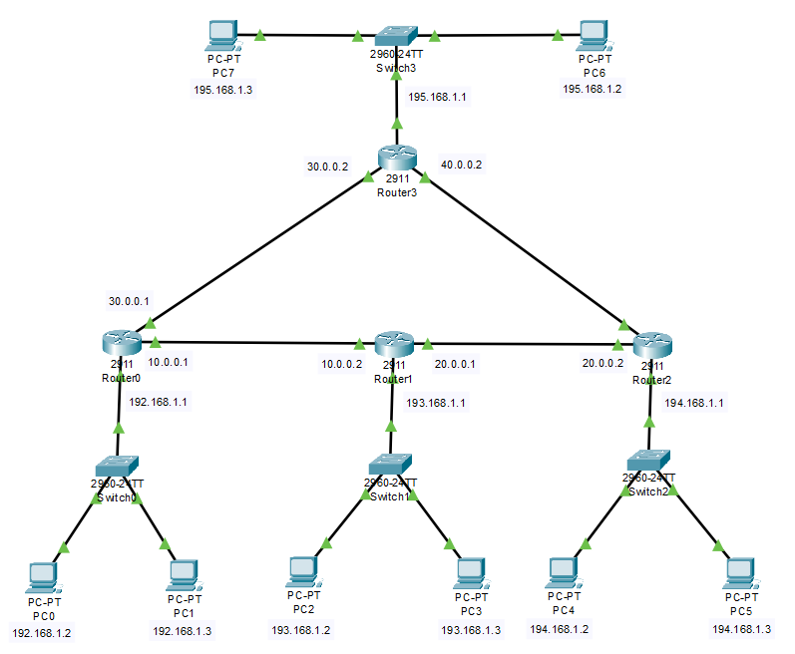

**Router-0:  
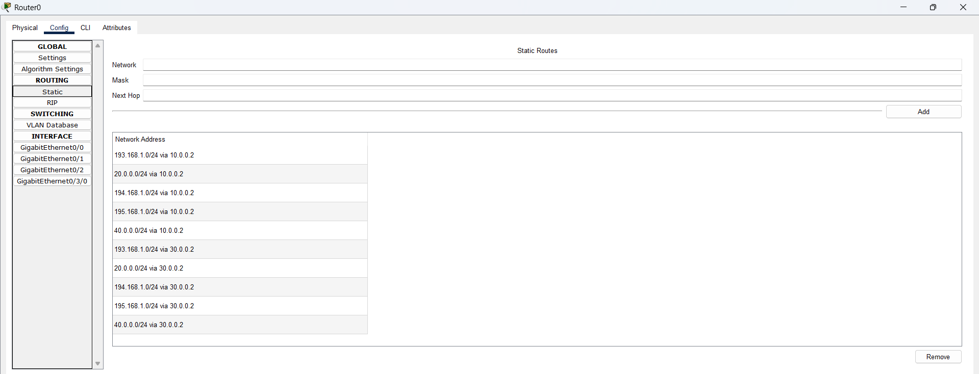 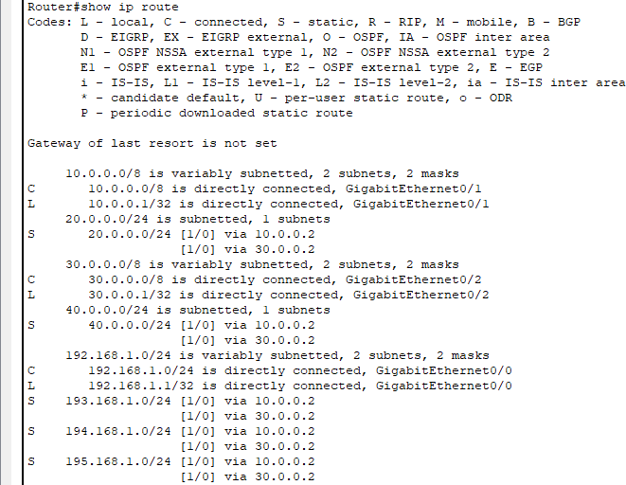**

**Router-1:**

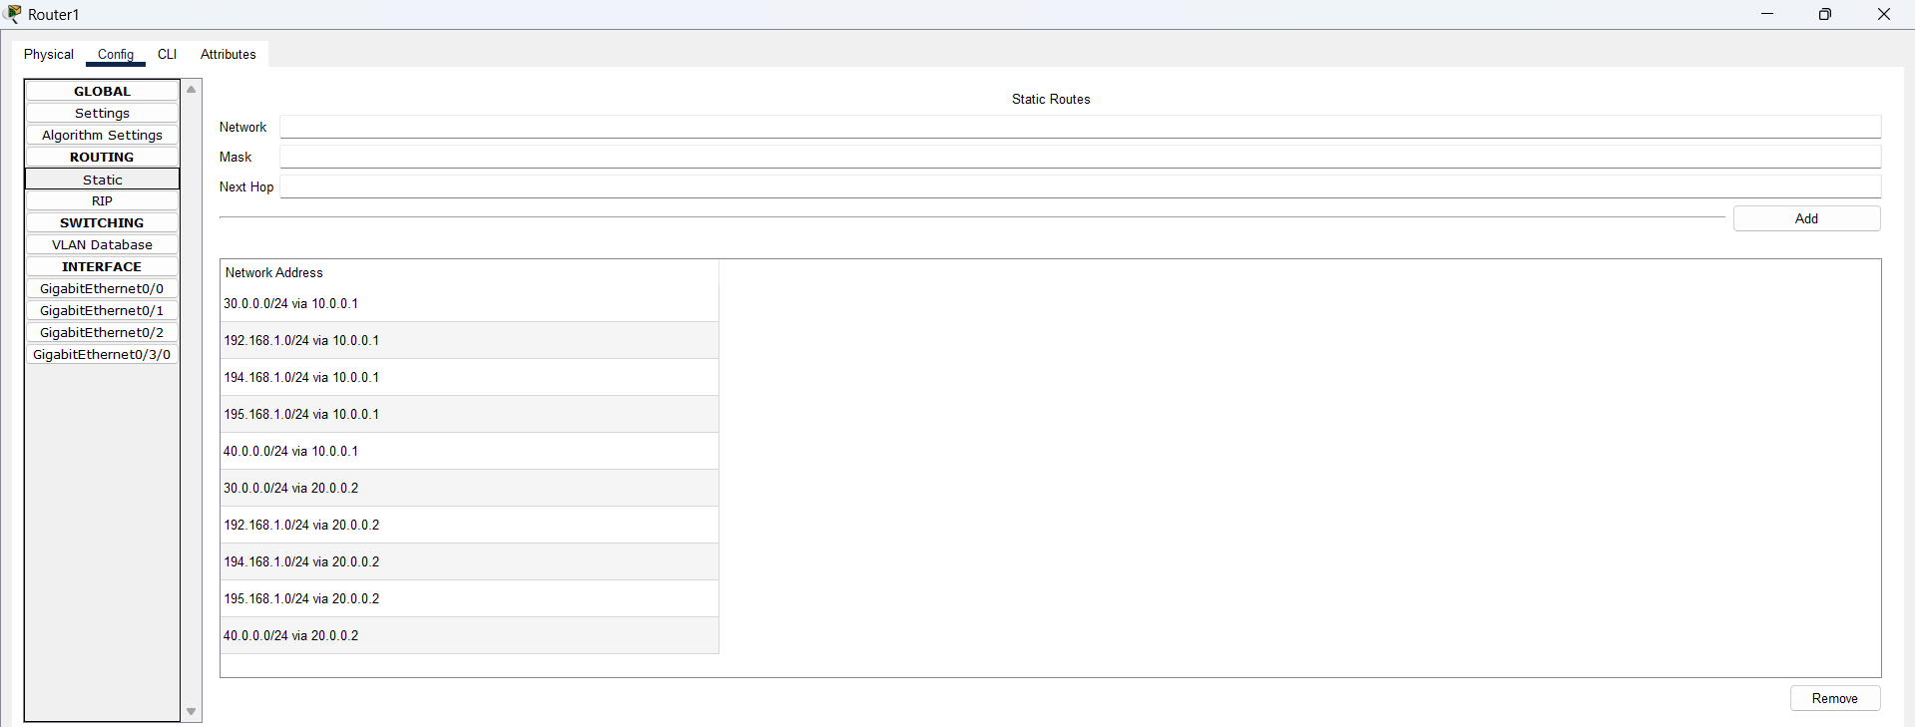 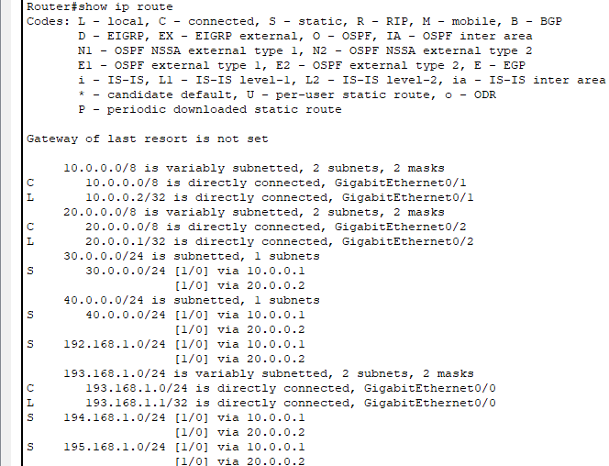

**Router-2:**

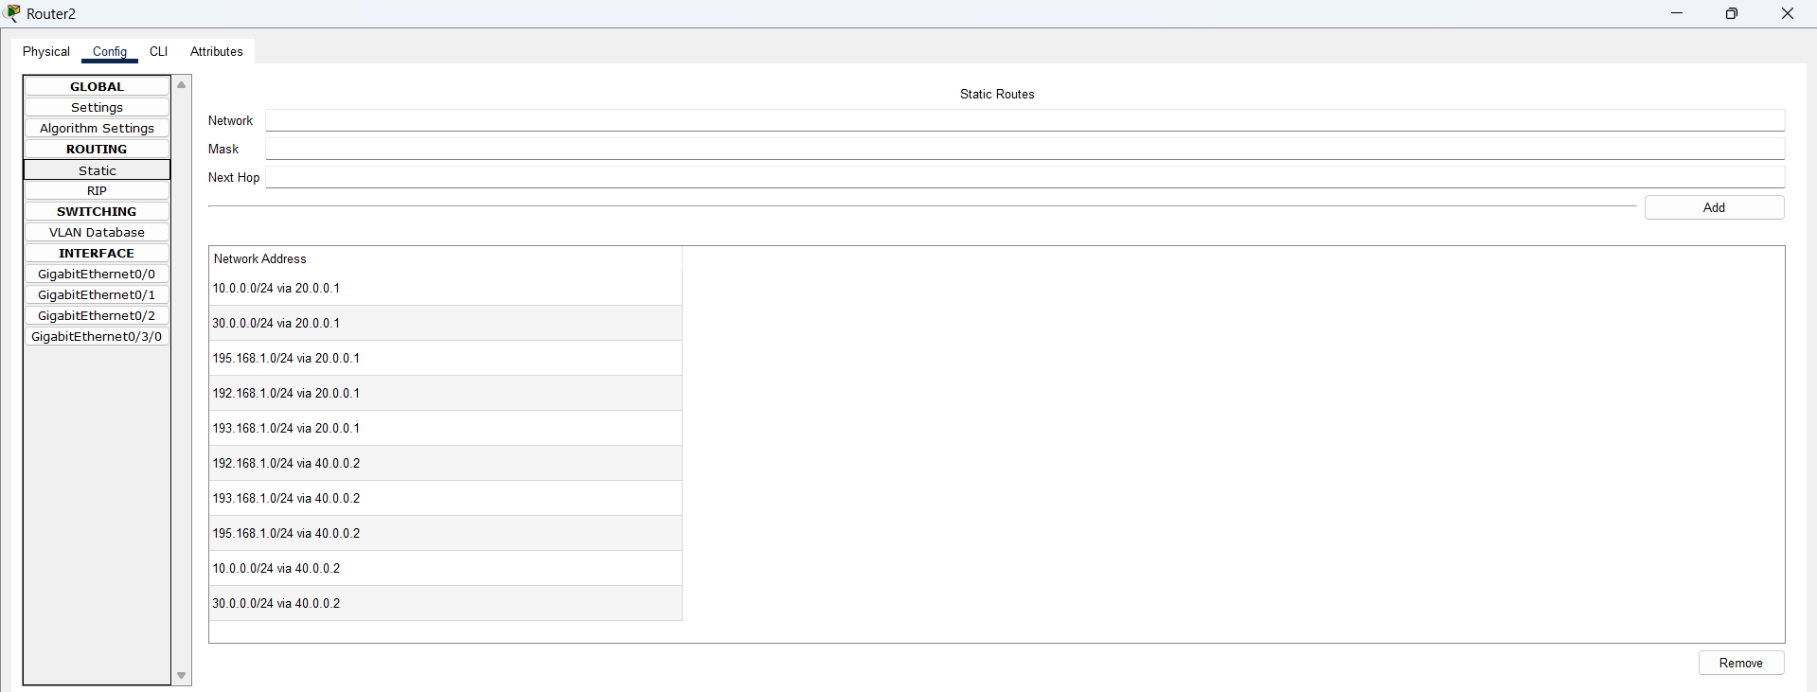 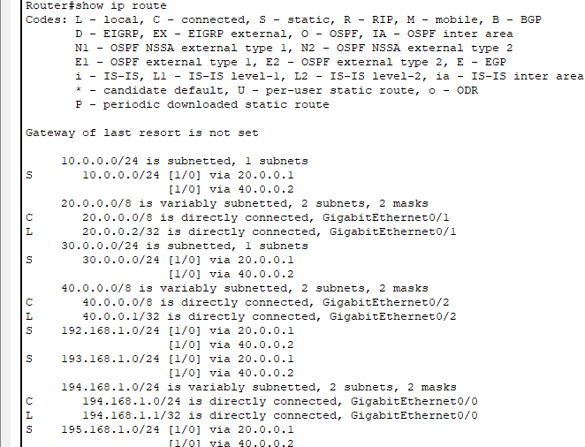

**Router-3:**

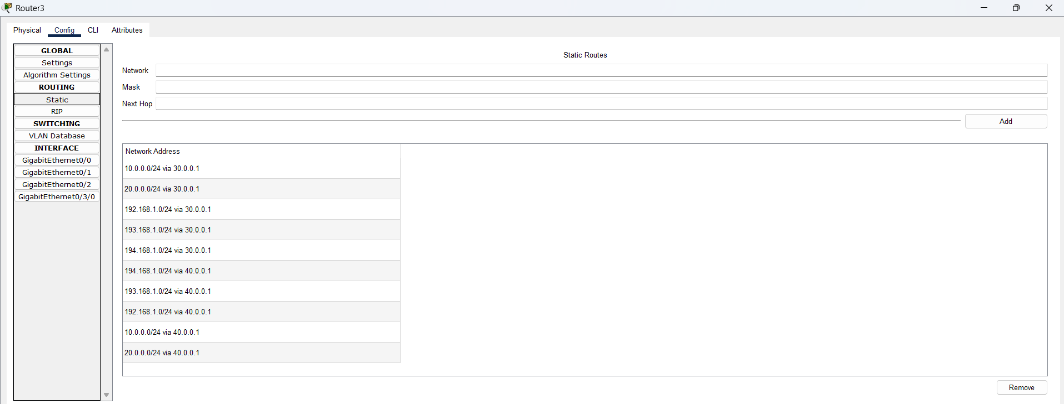 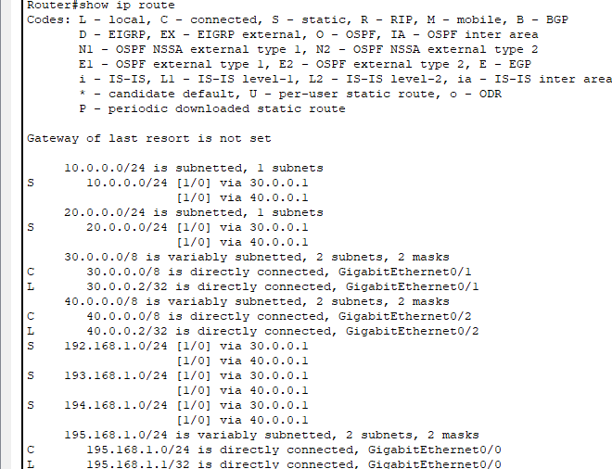

**We are able to ping all the end PC’s from PC0. This shows that the static routing was done correctly.**

